Spring 2022

California State University, Northridge

Department of Electrical & Computer Engineering

Final Project

Seven Segment Display

May 09, 2022

ECE 520

Written By: Christopher Y. Chen

**Purpose:**

This final project demonstrates how to implement a seven-segment display to display number or alphabets with zybo 7020 board while using the switches to control the output of the display. Additionally, we used an eight high brightness LED on the side just to verify the correct out and the pin mapping of the hardware PMOD ports. The seven-segment display will first display the number of 1 to 9, then every increment of number will continue with A, B, C …. F. The Four out of the eight LED will indicate the switch activation of each respective switches.

**Background:**

Pmods are defined by Digilent for small input and output interface boards to provides additional support and extension to the programmable development boards or embedded develop board systems. These Pmods module provides the developer to have sensitive signal conditioning circuits and high-power drive circuits to be placed near the sensor or the processing peripherals.

**Hardware list:**

1. PMOD Eight Liquid Crystal High Brightness LED (Figure 1)
2. Pmod Seven Segment LED Display
3. Pmod Switches
4. Zybo 7020

The **Pmod SSD** is a two-digit seven-segment display. To achieve the two digits shows up simultaneity, the developer needs to toggle at a rate of 50Hz to trick the human vision to think that is two digits lits up simultaneously. On the actual board, we used pin 1-6 of the JD and JE high speed Pmod port interfraces for the connect. As shown in the table below, we mapped the code in each respective pins to each respective i/o ports on zybo.

Figure

The **Pmod eight liquid crystal high brightness LED** utilizes individual transistors so that each LED can be turned on or off independently. I used the Pmod as the hexadecimal signal display guide for testing and troubleshooting the seven-segment display On the actual board, we used pin 1-6 of the JC high Pmod port interfraces for the connect. As shown in the table below, we mapped the code in each respective pins to each respective i/o ports on zybo.

Figure

The **Pmod Switch** utilizes four slide switches that users can use as a set of on and off switches or as a set of static binary inputs. Switch 1 will be the LSB and switch 4 will be the MSB.

Figure

Port Mapping:

Figure

Figure Zybo PMOD I/O port interfaces

**[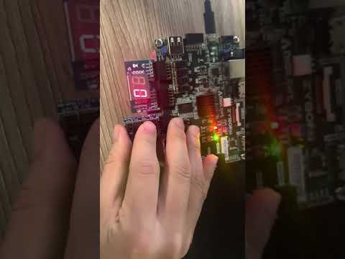](https://www.youtube.com/embed/sMvhzlptyao?feature=oembed)Code**:

The Code will check the switch status at every positive clock cycle. It will insert respective binary numbers into the segments. The respective segements for seven segements display are as follows: GFEDCBA to bits 87654321. At every posigive clock, the switch value will be also be inputed into the eight led and depends on the status of the switch, lights up each leds respectively.

**Conclusion:**

This is a very fun lab that helped me enforcing understanding of port mapping and simulating the project. The application of the seven-segment display are very common and can be found in most of the digital electronic that requires a display indication of the decimal data.